Onomy Exchange

At the core of the Onomy Exchange (ONEX) is the Market specification. The Market specification defines the application interface, the data structures and how that data mutates given valid user input and over intervals of time.

The ONEX is designed to support the order books of traditional financial markets as well as the automatic market maker liquidity pools that have become popular within decentralized exchanges such as Uniswap.

Add in explanation of the Automatic Market Maker and Order book functioning.

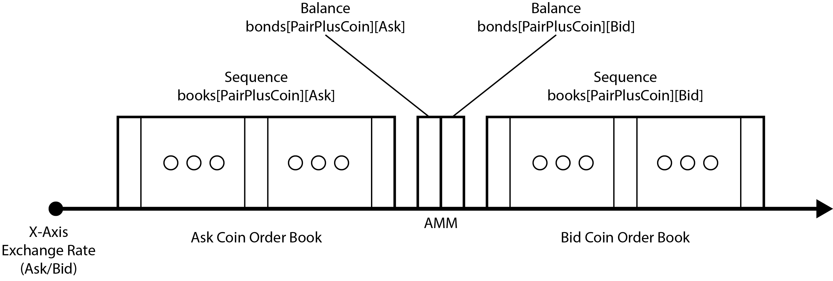

1. Trades

Trades involve the exchange two cryptographic tokens. The tokens are labeled based on the direction of the trade.

1. Terminology
   1. Chain

Decentralized network that secures transactions

* 1. Coin

A unit of value represented as a cryptographic token with a unique identifier

* 1. Ask Coin

The Ask Coin is received from the counterparty.

* 1. Bid Coin

The Bid Coin is paid to the counterparty.

* 1. Bridge

Networking component that facilitates transfer of coins between chains

1. Types
   1. Market Order

The market order is an immediately executed trade of a specified amount of the bid coin for the maximum amount of the ask coin.

* + - 1. Function:

MarketOrder(pair, bid coin, bid amount)

* + - * 1. Parameters:

Pair: Pair of coins exchanged.

Bid Coin: coin that is paid with the market order.

Bid Amount: amount of the bid coin paid.

* + - * 1. Returns:

Ask Amount: amount of the ask coin received.

* 1. Limit Order

The limit order specifies an amount of the bid coin and a limit to the exchange rate (ask coin amount / bid coin amount) at which the trade will be executed. Only the portion of the trade for which there is liquidity below or at the specified exchange will be immediately executed. The remaining amount, for which the exchange rate would be greater than the specified exchange rate, is entered into the order book at the specified exchange rate.

* + 1. Function

CreateLimitOrder(pair, bid coin, bid amount, expiration time)

* + - 1. Parameters:
         1. Pair: Pair of coins to be traded
         2. Bid Coin: The coin that is paid with the Limit Order
         3. Bid Amount: The amount of the bid coin paid with the Limit Order
         4. Expiration: The time at which the Swap will expire and the user that created the Swap, may withdraw the collateral.
      2. Returns:
         1. Order ID: cryptographic hash of the limit order transaction
    1. Function:

CloseLimitOrder(order id)

* + - 1. Parameters:
         1. Order ID: cryptographic hash of the limit order transaction
      2. Returns:
         1. Remainder: The remainder of the bid amount that was provided as part of the limit is refunded

Saved for the Reserve Overview: Swap minting is not part of the exchange and swaps are traded just as any other coins using the market protocol.

Swap

A Swap is a tokenized limit order that has an expiration date/time. The purpose of a Swap is to peg a specific coin to another coin at a specified exchange rate for a specified period of time. Swaps are valid until either the entire Swap amount has been exhausted or the expiration time is reached. Swaps do not affect liquidity of order books or automatic market maker and are represented by tradable coins.

Function:

CreateSwapOrder(pair, bid coin, bid amount, expiration time)

Parameters:

Pair: Pair of coins to be traded

Bid Coin: The coin that is paid with the Limit Order

Bid Amount: The amount of the bid coin paid with the Limit Order

Expiration: The time at which the Swap will expire and the user that created the Swap, may withdraw the collateral

Returns:

Swap Coin: The Swap token may be redeemed for the bid amount of the bid coin when surrendered with the ask amount of the ask coin before the expiration.

Function:

RedeemSwap(swap coin, ask amount)

Parameters:

Swap Coin: The coin that is paid with the Limit Order

Bid Amount: The amount of the bid coin paid with the Limit Order

Expiration: The time at which the Swap will expire and the user that created the Swap, may withdraw the collateral

Returns:

Swap Coin: The Swap token may be redeemed for the bid amount of the bid coin when surrendered with the ask amount of the ask coin before the expiration.

Function:

CloseSwapOrder(pair, bid coin, bid amount, expiration time)

Parameters:

Pair: Pair of coins to be traded

Bid Coin: The coin that is paid with the Limit Order

Bid Amount: The amount of the bid coin paid with the Limit Order

Expiration: The time at which the Swap will expire and the user that created the Swap, may withdraw the collateral

Returns:

Swap Coin: The Swap token may be redeemed for the bid amount of the bid coin when surrendered with the ask amount of the ask coin before the expiration.